**Quantum Computing In Artificial Intelligence: A Review Of Quantum Machine Learning Algorithms**

## ****ABSTRACT****

Two of the most disruptive technologies of the 21st century are quantum computing and artificial intelligence. Their intersection has led to the emergence of a new discipline referred to as Quantum Machine Learning (QML), which attempts to improve the capabilities of classical machine learning by leveraging the computational supremacy of quantum devices. This paper provides a survey of the most advanced QML algorithms, such as Quantum Support Vector Machines (QSVMs), Quantum k-Nearest Neighbors (QkNN), Quantum Principal Component Analysis (QPCA), Quantum Neural Networks (QNNs), and Quantum Reinforcement Learning (QRL). The theoretical and practical status, as well as empirical performance, of these algorithms were summarized with a structured review method. The findings reveal a potential for speed-ups in classification, clustering, and optimization among a range of applications, particularly for perfect quantum systems. However, practical utility has been restricted by hardware constraints, software irregularities, and training issues such as barren plateaus. Applications of QML in areas such as NLP, drug discovery, and finance demonstrate both the potential and current limitations of QML, with most applications still at the proof-of-concept level. In this review, we conclude that QML could be revolutionary, but its feasibility ultimately relies on improvements in physical hardware, the robustness of algorithms, and the standardization of benchmarks.

**Keywords:** Artificial Intelligence, Machine Learning, Quantum Algorithms, Quantum Computing, Quantum Machine Learning

**1. Introduction**

**1.1 Background**

Artificial intelligence (AI) has become one of the most transformative technologies of the 21st century and has, in large part, opened up new possibilities for machines to accomplish tasks that would require human intelligence. From speech recognition to self-driving cars and healthcare diagnosis, AI has a broad range of applications. At the heart of AI is the ability to use machine learning (ML) to recognize patterns in the data, to make predictions, and to get better over time. But with explosive accumulations of data and complexity, the use of classical ML models often presents high computational loads, which lead to the need for very powerful computational resources and training time (Collins et al., 2021).

Ascular with the progress made in AI, Quantum Computing (QC) is becoming an emerging new paradigm for information processing. Rather than the binary bits (0s and 1s) used in classical computers, quantum computers work with quantum bits (qubits) that leverage superposition and entanglement. Such quantum nature allows exponentially larger computational power,  therefore leading to the possibility of solving significantly more problems than can be done on a classical computer(Memon et al., 2024).

**1.2 Motivation**

Intertwinement: AI and QC This convergence of AI and QC has sparked a new field of research, namely Quantum Machine Learning (QML). QML aims to improve the performance of ML algorithms with the help of quantum mechanics. The rationale behind this merge is to address some limitations of classical ML models, namely, speed, scalability, and management of high-dimensional data. Quantum-enhanced NISQ algorithms have demonstrated the potential to cut down computational overhead, optimize models more effectively, and even find previously unknown solutions for known problems(Devadas & T, 2025a).

Quantum Machine Learning (QML) is gaining enthusiastic attention with the evolution of both quantum hardware and quantum software ecosystems. Academia and industry are both investing in quantum research,  and IBM, Google, and D-Wave are among the companies that have developed quantum systems open for QML exploration. However, despite this recent surge, we are still in the early days, with a coherent picture of what algorithms exist and what they can and cannot do only beginning to emerge.

**1.3 Objective of the Review**

The objective of this review is to give an understanding of Quantum Machine Learning algorithms, in terms of theoretical background, computational benefits, and applicability. We aim to:

Describe prominent quantum ML algorithms such as Q-SVM, QNN, and Qk-NN.

Provide some insight on the latest developments, deployed tools, and experimental outcomes.

Assess practical problems and future research directions in QML.

In this work, we aim at guiding researchers, practitioners, and students to the state-of-the-art of quantum computing for artificial intelligence by surveying what has been done in the field so far, as well as by presenting recent advances.

## ****2. Literature Review****

### ****2.1 Evolution of Quantum Computing in AI****

The field of artificial intelligence and quantum computing intersection is not new, going back to a few decades on a solely theoretical basis. One of the earliest and most influential of these ideas was that of quantum information theory, developed by Bennett and Wiesner (1992), and the groundwork of applying quantum ideas to encode and transmit data(Barnett, n.d.). Shor’s algorithm (1994) and Grover’s algorithm (1996) revealed the potential for quantum computers to provide a computational advantage over classical computers in certain problems, provoking researchers to investigate quantum-enhanced AI models(*Shor’s Algorithm and Grover’s Algorithm in Quantum Computing*, n.d.).

At the turn of the millennium, scientists started looking into the ways quantum systems might help out with machine learning tasks,  such as optimization and pattern recognition(Devadas & T, 2025b). This gave rise to the notion of Quantum Machine Learning (QML), in which a quantum system is treated as a data processor. Noisy Intermediate-Scale Quantum (NISQ) devices, such as those available from companies like IBM, Google, and Rigetti, have made applied experimentation with QML algorithms feasible in the 2010s. This shift marked the transition from theoretical promise to empirical exploration(Bharti et al., 2022).

For providing a context in which to consider the emergence of QML, one needs to reflect on the history of the common tradition of quantum computing and AI. From the (very) early days of quantum information theory to recent developments in NISQ and hybrid algorithm, the evolution of this field epitomizes the passage from theoretical potentiality to empirical practice. These critical moments of progress are consolidated in Fig. 1.

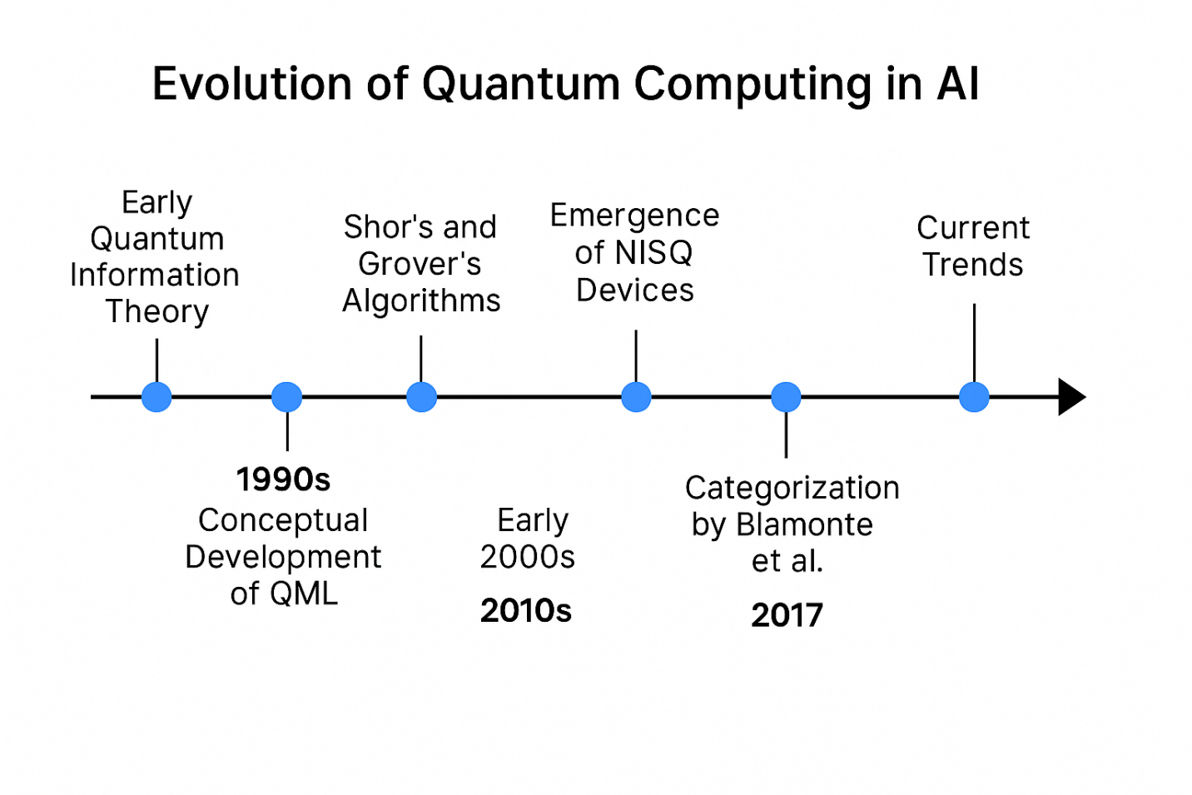

**Figure 1: Evolution of Quantum Computing in Artificial Intelligence**. This timeline illustrates key milestones in the evolution of quantum computing and its integration with artificial intelligence, highlighting theoretical foundations, algorithmic breakthroughs, and the emergence of practical quantum platforms. Notably, Biamonte et al. (2017) categorized QML research into four areas: quantum data with quantum algorithms, classical data with quantum algorithms, quantum data with classical algorithms, and hybrid systems. This classification remains a cornerstone for understanding how and where quantum computing enhances machine learning capabilities.

### ****2.2 Review of Classical ML Limitations****

The conventional ML models, in particular DL models, are typically computationally expensive: for example, for training models (e.g., high-dimensional, unstructured data), the cost is rather high. Optimization of millions of parameters, as in training neural networks, for example, can be time-consuming and costly from an energy perspective. SVMs such as the one in (Baudat & Anouar, 2000) have proven to be effective methods in the context of case-based reasoning, but scale poorly with the size of the dataset, since the complexity of such algorithms can be polynomial or exponential in the worst case(Safonova et al., 2023; Taye, 2023)

Furthermore, classical ML cannot handle problems with very large search spaces (e.g., combinatorial optimization) and may get stuck in local minima. Quantum approaches to optimize and transform data, exploiting quantum parallelism and entanglement, have then been investigated(Ranga et al., 2024).

Quantum mechanics provides a superior power in processing complex probability distributions and high-dimensional vector spaces compared to classical computers. Quantum Principal Component Analysis (QPCA) uses quantum parallelism to compute principal components exponentially faster than classical PCA in the worst case (Bellante et al., 2022). These benefits place QML as a remedy against some of the most glaring bottlenecks of classical ML.

### ****2.3 Existing Surveys and Gaps****

Several review papers and surveys have attempted to surveyed the QML landscape. For example, Dunjko and Briegel (2018) investigated the fundamental mechanics of quantum-enhanced learners with a particular focus on the reinforcement model for agents operating in a quantum environment(Dunjko et al., 2017). Schuld and Petruccione (2018) offered a practical introduction to QML algorithms, such as learning with quantum data encoding and quantum circuit design for novices(Schuld et al., 2015). More recent: elements of works such as Benedetti et al. (2019) have treated variational quantum classifiers and hybrid models that employ classical optimizers in conjunction with quantum feature maps(Benedetti et al., 2019).

Although such reviews were valuable in defining the research program, they are either theoretical or application-oriented. However, there is a lack of systematic studies of full-round comparison models of various QML algorithms and evaluations regarding computational complexity and significance to human-centered practical AI processes. Moreover, little to no existing reviews focus on hardware-software integration challenges, especially as relates to hybrid quantum-classical devices, which are becoming more important in the context of NISQ-era devices.

Another under-investigated area would be to benchmark QML algorithms on realistic datasets, as most of their performances are claimed or are exhibited on synthetic datasets. The scaling and robustness of QML models to noise and uncertainty have not yet been compared against state-of-the-art classical approaches in a longitudinal study.

In order to overcome these shortcomings, the objective of this review is to connect theoretical advances and practical usages of QML by performing a comparative review for QML algorithms with respect to their theoretical promise as well as empirical performance. And it highlights future research directions, in particular in benchmarking, quantum data preparation, and algorithmic robustness.

**3. Methodology**

**3.1 Review Methodology**

This review follows a structured narrative methodology aimed at synthesizing the current landscape of Quantum Machine Learning (QML) algorithms. The objective is not only to summarize key quantum learning models but also to critically assess their theoretical underpinnings, computational potential, and empirical performance. To ensure comprehensive coverage, a multi-step literature selection and analysis process was adopted.

Relevant scholarly sources were identified using academic databases including IEEE Xplore, SpringerLink, ScienceDirect, arXiv, and Google Scholar. The primary keywords used were: *Quantum Machine Learning*, *Quantum Algorithms in AI*, *Quantum Neural Networks*, *Quantum SVM*, and *Variational Quantum Circuits*. The search was limited to publications from 2014 to 2024, a period that captures the emergence of practical quantum computing platforms and experimental QML implementations.

Inclusion criteria for selected articles included:

* Peer-reviewed journal articles or well-cited preprints.
* Explicit focus on machine learning techniques applied or adapted to quantum computation.
* Clear description of algorithmic methodology, performance claims, or real-world applications.
* Contributions to hardware-software integration or performance benchmarking.

Articles were excluded if they lacked technical detail, were purely conceptual without implementation context, or focused solely on quantum physics without links to AI or ML. After the initial filtering, approximately 60 papers were shortlisted and analyzed. Each algorithm discussed in this review is examined across three core criteria: algorithmic structure, computational complexity, and implementation feasibility on current quantum systems.

**3.2 Mathematical Foundations**

Linear algebra of Quantum states and manipulation of probability amplitudes in high-dimensional Hilbert spaces is the foundation of Quantum Machine Learning (QML) algorithms. For consistency and ease of understanding, Dirac formalism (|ψ⟩), quantum gates (such as Hadamard and Pauli-X), and unitary operators (U) are used in the present review. When appropriate, classical mathematical counterparts—such as inner products, eigenvalue decompositions, and kernel functions—are provided in tandem with their quantum analogs for the sake of comparison(*Linear Algebra for Quantum Computing | Quantum Computing Class Notes | Fiveable | Fiveable*, n.d.).

For example, the Quantum Support Vector Machine (QSVM) makes use of the quantum kernel trick, where a pair of classical inner products is replaced by calculating quantum kernels using the fidelity between quantum states:

K(xi​,xj​)=∣⟨ϕ(xi​)∣ϕ(xj​)⟩∣2

Similarly, Quantum Principal Component Analysis (QPCA) leverages the representation of data as density matrices. It utilizes quantum phase estimation algorithms to approximate eigenvalues with exponential speed-ups under idealized quantum conditions:

ρ=i∑​λi∣vi​⟩⟨vi​∣

The review also encompasses hybrid quantum-classical variational algorithms in which parameterized quantum circuits (PQCs) are optimized with classical routines, such as gradient descent. Such hybrid models have become particularly relevant nowadays in the NISQ (Noisy Intermediate-Scale Quantum) era, where quantum circuits can be trained on noisy devices with classical optimization loops.

Purely mathematical formulations are extracted from literature in the course of the analysis, as we do not wish to make any initial assumptions on them, seeking clarity, reproducibility, and compliance with standard quantum computing formalism.

## ****4. Results and Discussion****

### ****4.1 Overview of Key Quantum Machine Learning Algorithms****

Presenting the most important features of the different Quantum Machine Learning (QML) algorithms comparatively can help grasp a better view of these. In Fig.2, we have presented the main QML models considering their task domains, basic quantum mechanics, theoretical speed-up prospects, and implementation levels of maturity. This “side-by-side” perspective reinforces the flexibility and applicability of QML approaches, while also pointing out the realisation gap. Quantum Machine Learning (QML) algorithms are generally grouped according to the type of learning paradigm that they tackle, namely supervised, unsupervised, and quantum reinforcement learning. Several promising algorithms have been created, aimed at taking advantage of quantum features (such as superposition and entanglement) to achieve faster learning and better scalability(Ajibosin & Cetinkaya, 2024; Ghobadi & Afsaneh, 2024).

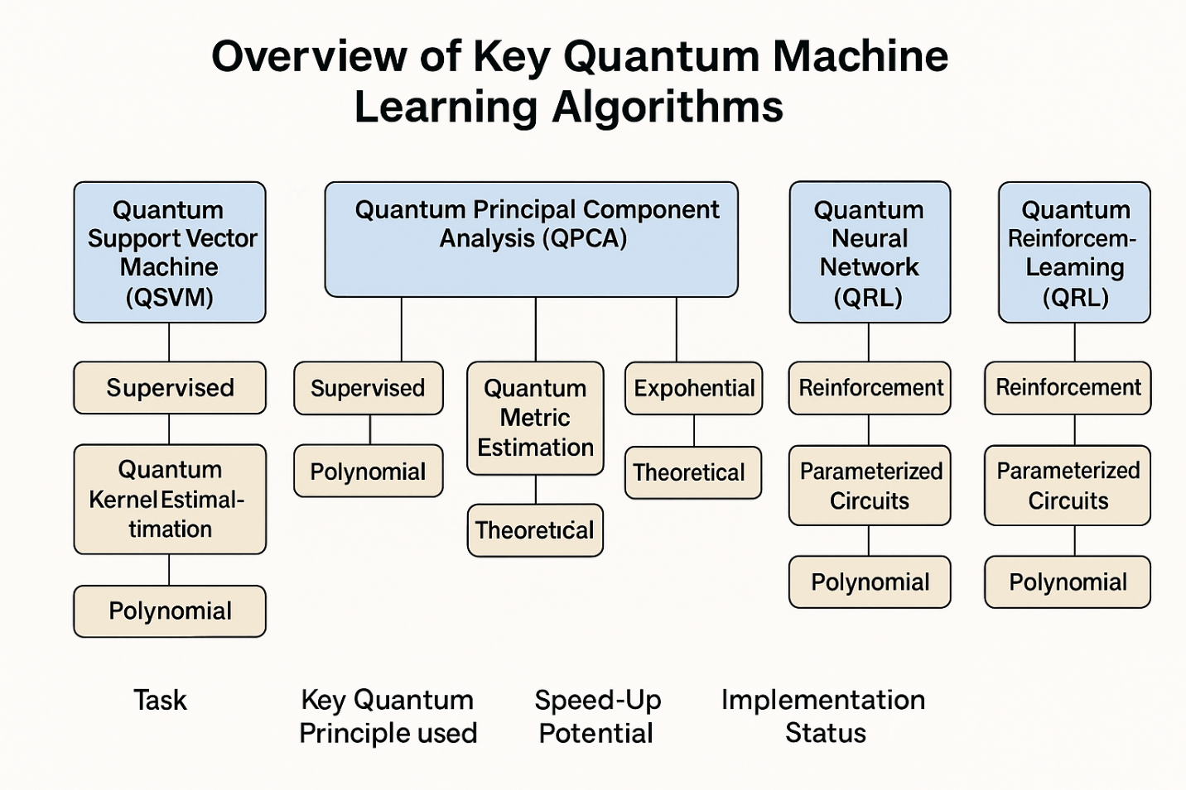

**Figure 2: Comparative Overview of Key Quantum Machine Learning Algorithms**. This flowchart presents a comparative overview of prominent Quantum Machine Learning (QML) algorithms, detailing their learning paradigms, key quantum principles, potential computational speed-ups, and current implementation status. The diagram emphasizes the diverse approaches and challenges associated with each algorithm in the context of AI tasks.

**Quantum Support Vector Machines (QSVM)**

It is known that QSVMs rely on quantum-enhanced kernel methods to perform classification. The main advantage is provided by quantum kernel estimation, where the fidelity-based fidelity between two quantum states is used as a similarity measure. This allows for possibly exponential speed-ups in high-dimensional feature spaces(Schnabel & Roth, 2025). Implemented a hybrid QSVM on a physical quantum computer, where data were encoded into quantum circuits, via a feature map, and classified them with little difference in performance compared to classical models.

**QUANTUM k-Nearest Neighbors (QKNN)**

The QkNN procedure for distance computation. The QkNN algorithm computes distances between quantum states using inner products between qubit code vectors. We use quantum state fidelity instead of Euclidean distance. Machine learning algorithms such as those of Wiebe and others demonstrate substantial computational advantages, particularly in memory accesses, from quantum random access memory (qRAM), but qRAM technology is currently largely a theoretical concept(Gao et al., 2022).

**Quantum Principal Component Analysis (QPCA)**

QPCA is designed to extract the most significant eigenvectors from a density matrix representation of quantum data. Introduced by Lloyd et al. (2014), the method uses quantum phase estimation to retrieve principal components exponentially faster than classical PCA under certain constraints. Although promising, current QPCA implementations are limited by decoherence and require precise control of quantum systems(Li et al., 2021).

**Quantum neural networks (QNNS)**

QNNs aim to replicate the layered structure of classical neural networks using quantum gates and circuits. They typically involve parametrized quantum circuits (PQCs) that are optimized via classical gradient descent. Notable architectures include the **Quantum Perceptron** and **Variational Quantum Classifiers** (VQCs), which have demonstrated feasibility for small-scale classification tasks on IBM Q and other platforms (Schuld et al., 2015). However, training is sensitive to vanishing gradients—a problem termed **barren plateaus**—limiting scalability.

**Quantum Reinforcement Learning (QRL)**

Quantum reinforcement learning explores the use of quantum systems as decision-making agents. Hu 2018 proposed quantum agents that can outperform classical strategies in Markov decision processes through entanglement-assisted learning. QRL remains largely theoretical due to the complexity of quantum feedback loops and the lack of interactive quantum environments(Hu, 2018).

### ****4.2 Performance and Benchmarks****

Comparisons of QML algorithms are still hard due to the fact of the naissance of the quantum hardware, and most importantly there are no publicly available standard datasets. But there are some early signals in several studies about performance.

For instance, the QSVM on IBM superconducting qubits yielded competitive classification accuracy with classical SVMs for small datasets, while the kernel computation on a quantum device exhibited impressive speed-ups. Simulator and 5–7 qubit devices have also been trained with QNNs with binary classiﬁcation tasks, but as the number of qubits increases, the noise degrades performance(Devadas & T, 2025b).

Theoretical analysis predicts that, by using the combination of QPCA (or QFT), a speed-up of exponential scaling dimension of a data space is achievable for learning latent structures in extensive datasets. Despite this, the performance of experiments is often well below the theoretical limit, and a gap between idealized and practical performance is observed. **A summary of algorithm performance characteristics** is provided in Table 1**.**

| **Algorithm** | **Task Type** | **Speed-up Potential** | **Implementation Status** | **Key Limitation** |
| --- | --- | --- | --- | --- |
| QSVM(Montalbano & Banchi, 2025) | Supervised | Polynomial to Exponential | Early-stage hardware | Quantum kernel estimation noise |
| QkNN(Lawal et al., 2025) | Supervised | Polynomial | Mostly theoretical | qRAM impracticality |
| QPCA(Chaudhry et al., 2023) | Unsupervised | Exponential (idealized) | Simulated/early-stage | Requires pure state input |
| QNN/VQC(Chaudhry et al., 2023) | Supervised | Moderate (hybrid) | Implemented on NISQ | Barren plateaus in training |
| QRL(Gao et al., 2022) | Reinforcement | Unknown | Theoretical | Lack of quantum feedback systems |

**Table 1. Summary of performance and implementation status of key QML algorithms.**

### ****4.3 Practical Applications****

QML algorithms are slowly getting practical applications in fields where classical ML has a hard time with dimensionality or optimization scale.

· **Quantum-enhanced natural language processing (QNLP)** is being explored using tensor networks and quantum circuits to represent grammatical structure and semantic relationships(Coecke et al., 2020).

·  Drug discovery and molecular simulation are aided by incorporating quantum chemistry with QML methods to predict molecular properties or results of quantum simulations.

· Quantum optimization routines (e.g., Quantum Approximate Optimization Algorithm, QAOA) are being used to model finance and risk, including portfolio optimization and fraud, waste, and abuse detection.

· There are also recent results showing that some recommendation systems (similar to ones considered in Kerenidis and Prakash can be computed much faster in the high-dimensional user-item matrix setting compared to classical settings(Kerenidis & Prakash, 2016). However, the majority of the applications are still in the proof-of-concept phase and have been tested only with relatively small datasets and under controlled environments.

### ****4.4 Limitations and Challenges****

Although QML is highly promising from a theoretical perspective, there are many challenges to confront:

·  The lack of hardware is still the biggest issue. NISQ processors are high-noise, coherently limited gates with short T1 times and low T2 times. Scaling beyond 100 qubits remains a challenge for the majority of quantum hardware.

· The software and tooling landscape is fragmented, with frameworks such as Qiskit, Pennylane, and Cirq providing a variety of capabilities but no consistent user experience. There are no standard APIs and benchmarking tools.

· Data encoding (through quantum feature maps) is not trivial and often mitigates speed-ups when the classical-to-quantum transformation of the data is costly.

· Barren plateaus — regions of the optimization landscape where gradients are extremely close to zero ¬-- hamper training of deep quantum neural networks(Karuppasamy et al., 2025; Pfaendler et al., 2024).

The absence of large quantum datasets also hinders experimentation. Simulations of classical systems are computationally costly and inconclusive with respect to quantum behavior.

In summary, while theoretical results are still reaching new frontiers, practical implementation of QML is as much constrained by engineering as by algorithmic foundations.

## ****5. Conclusions****

In this paper, we have discussed the emerging research area of Quantum Machine Learning (QML), where we celebrate quantum techniques to improve on classical artificial intelligence algorithms. The synergy of qubit-type computation with machine learning algorithms suggests some interesting possibilities to go beyond the limitations of classical models in terms of such as computation complexity and effectiveness.

The fundamental algorithms such as QSVMs, QkNN, QPCA, and QNNs have different levels of theoretical and practical prospects. Although some quantum models provide exponential or polynomial acceleration in kernel estimation, classification, and unsupervised learning, they are often restricted to experience hardware limitations induced by the NISQ (Noisy Intermediate-Scale Quantum) technologies. Experimental works and early applications demonstrate feasibility on small quantum devices, while deployment in practical applications remains challenging due to decoherence, low qubit numbers, and intricate training behaviour, such as barren plateaus.

In applications, QML has demonstrated early successes in natural language processing, drug design, financial modeling, and recommendation systems. Yet, such applications are primarily experimental and heavily based on simulations or limited datasets. Moreover, standard benchmarks and datasets of rigorous performance evaluation do not exist for comparison with classical counterparts.

While the review of the experimental status below shows encouraging progress, the road ahead for QML requires, and is in turn premised on, further progress on quantum hardware, on the construction of scalable but fault-tolerant quantum algorithms (typically hybrid in nature and quantum/classical in execution), and highly integrated quantum-classical software stacks. It is also necessary to pay attention to the interpretability of the algorithms and to analyze domain-specific quantum advantages. Although challenges persist, quantum computing and machine learning appear to be on the brink of reshaping the computational underpinnings of artificial intelligence over a range of coming decades.

REFERNCES

Ajibosin, S. S., & Cetinkaya, D. (2024). Implementation and Performance Evaluation of Quantum Machine Learning Algorithms for Binary Classification. *Software*, *3*(4), Article 4. https://doi.org/10.3390/software3040024

Barnett, S. M. (n.d.). *Introduction to Quantum Information*.

Bellante, A., Luongo, A., & Zanero, S. (2022). Quantum algorithms for SVD-based data representation and analysis. *Quantum Machine Intelligence*, *4*(2), 20. https://doi.org/10.1007/s42484-022-00076-y

Benedetti, M., Lloyd, E., Sack, S., & Fiorentini, M. (2019). Parameterized quantum circuits as machine learning models. *Quantum Science and Technology*, *4*(4), 043001. https://doi.org/10.1088/2058-9565/ab4eb5

Bharti, K., Cervera-Lierta, A., Kyaw, T. H., Haug, T., Alperin-Lea, S., Anand, A., Degroote, M., Heimonen, H., Kottmann, J. S., Menke, T., Mok, W.-K., Sim, S., Kwek, L.-C., & Aspuru-Guzik, A. (2022). Noisy intermediate-scale quantum (NISQ) algorithms. *Reviews of Modern Physics*, *94*(1), 015004. https://doi.org/10.1103/RevModPhys.94.015004

Chaudhry, M., Shafi, I., Mahnoor, M., Vargas, D. L. R., Thompson, E. B., & Ashraf, I. (2023). A Systematic Literature Review on Identifying Patterns Using Unsupervised Clustering Algorithms: A Data Mining Perspective. *Symmetry*, *15*(9), Article 9. https://doi.org/10.3390/sym15091679

Coecke, B., Felice, G. de, Meichanetzidis, K., & Toumi, A. (2020). *Foundations for Near-Term Quantum Natural Language Processing* (No arXiv:2012.03755). arXiv. https://doi.org/10.48550/arXiv.2012.03755

Collins, C., Dennehy, D., Conboy, K., & Mikalef, P. (2021). Artificial intelligence in information systems research: A systematic literature review and research agenda. *International Journal of Information Management*, *60*, 102383. https://doi.org/10.1016/j.ijinfomgt.2021.102383

Devadas, R. M., & T, S. (2025a). Quantum machine learning: A comprehensive review of integrating AI with quantum computing for computational advancements. *MethodsX*, *14*, 103318. https://doi.org/10.1016/j.mex.2025.103318

Devadas, R. M., & T, S. (2025b). Quantum machine learning: A comprehensive review of integrating AI with quantum computing for computational advancements. *MethodsX*, *14*, 103318. https://doi.org/10.1016/j.mex.2025.103318

Dunjko, V., Taylor, J. M., & Briegel, H. J. (2017). Advances in Quantum Reinforcement Learning. *2017 IEEE International Conference on Systems, Man, and Cybernetics (SMC)*, 282–287. https://doi.org/10.1109/SMC.2017.8122616

Gao, L.-Z., Lu, C.-Y., Guo, G.-D., Zhang, X., & Lin, S. (2022). Quantum K-nearest neighbors classification algorithm based on Mahalanobis distance. *Frontiers in Physics*, *10*. https://doi.org/10.3389/fphy.2022.1047466

Ghobadi, M. Z., & Afsaneh, E. (2024). Potential of quantum machine learning for solving the real-world problem of cancer classification. *Discover Applied Sciences*, *6*(10), 513. https://doi.org/10.1007/s42452-024-06220-6

Hu, W. (2018). Empirical Analysis of Decision Making of an AI Agent on IBM’s 5Q Quantum Computer. *Natural Science*, *10*(1), Article 1. https://doi.org/10.4236/ns.2018.101004

Karuppasamy, K., Puram, V., Johnson, S., & Thomas, J. P. (2025). A Comprehensive Review of Quantum Circuit Optimization: Current Trends and Future Directions. *Quantum Reports*, *7*(1), Article 1. https://doi.org/10.3390/quantum7010002

Kerenidis, I., & Prakash, A. (2016). *Quantum Recommendation Systems* (No. arXiv:1603.08675). arXiv. https://doi.org/10.48550/arXiv.1603.08675

Lawal, O. P., Egwuatu, E. C., Akanbi, K. O., Orobator, E. T., Eweje, O. Z., Omotayo, E. O., Igbokwe, C., Ogundeko-Olugbami, O., Awuah, S. B., Chibueze, E. S., Lawal, O. P., Egwuatu, E. C., Akanbi, K. O., Orobator, E. T., Eweje, O. Z., Omotayo, E. O., Igbokwe, C., Ogundeko-Olugbami, O., Awuah, S. B., & Chibueze, E. S. (2025). Fighting Resistance With Data: Leveraging Digital Surveillance to Address Antibiotic Misuse in Nigeria. *Path of Science*, *11*(3), Article 3. https://doi.org/10.22178/pos.115-25

Li, Z., Chai, Z., Guo, Y., Ji, W., Wang, M., Shi, F., Wang, Y., Lloyd, S., & Du, J. (2021). Resonant quantum principal component analysis. *Science Advances*, *7*(34), eabg2589. https://doi.org/10.1126/sciadv.abg2589

*Linear algebra for quantum computing | Quantum Computing Class Notes | Fiveable | Fiveable*. (n.d.). Retrieved May 14, 2025, from https://library.fiveable.me/quantum-computing/unit-9/linear-algebra-quantum-computing/study-guide/Cc4WgWVUYDq4oZjr

Memon, Q. A., Al Ahmad, M., & Pecht, M. (2024). Quantum Computing: Navigating the Future of Computation, Challenges, and Technological Breakthroughs. *Quantum Reports*, *6*(4), Article 4. https://doi.org/10.3390/quantum6040039

Montalbano, G., & Banchi, L. (2025). Quantum adversarial learning for kernel methods. *Quantum Machine Intelligence*, *7*(1), 15. https://doi.org/10.1007/s42484-025-00238-8

Pfaendler, S. M.-L., Konson, K., & Greinert, F. (2024). Advancements in Quantum Computing—Viewpoint: Building Adoption and Competency in Industry. *Datenbank-Spektrum*, *24*(1), 5–20. https://doi.org/10.1007/s13222-024-00467-4

Ranga, D., Rana, A., Prajapat, S., Kumar, P., Kumar, K., & Vasilakos, A. V. (2024). Quantum Machine Learning: Exploring the Role of Data Encoding Techniques, Challenges, and Future Directions. *Mathematics*, *12*(21), Article 21. https://doi.org/10.3390/math12213318

Safonova, A., Ghazaryan, G., Stiller, S., Main-Knorn, M., Nendel, C., & Ryo, M. (2023). Ten deep learning techniques to address small data problems with remote sensing. *International Journal of Applied Earth Observation and Geoinformation*, *125*, 103569. https://doi.org/10.1016/j.jag.2023.103569

Schnabel, J., & Roth, M. (2025). Quantum kernel methods under scrutiny: A benchmarking study. *Quantum Machine Intelligence*, *7*(1), 58. https://doi.org/10.1007/s42484-025-00273-5

Schuld, M., Sinayskiy, I., & Petruccione, F. (2015). An introduction to quantum machine learning. *Contemporary Physics*, *56*(2), 172–185. https://doi.org/10.1080/00107514.2014.964942

*Shor’s Algorithm and Grover’s Algorithm in Quantum Computing*. (n.d.). Retrieved May 14, 2025, from https://kuscholarworks.ku.edu/entities/publication/e00ad7bd-e57e-41d4-9c64-0ba1b9458673

Taye, M. M. (2023). Understanding of Machine Learning with Deep Learning: Architectures, Workflow, Applications, and Future Directions. *Computers*, *12*(5), Article 5. https://doi.org/10.3390/computers12050091